cordially invites residents of
Hershey’s Mills to
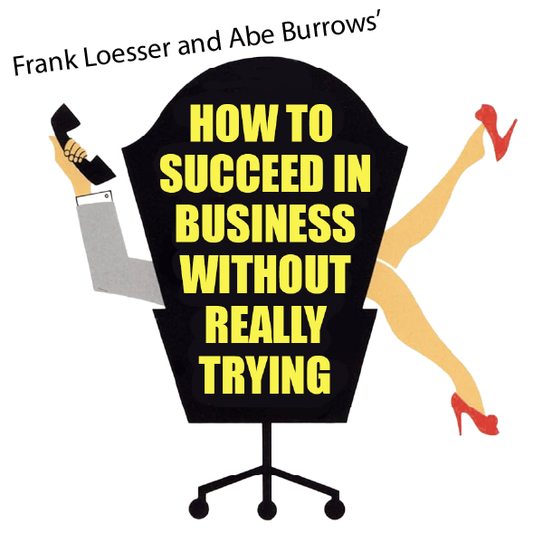

APRIL 18, 19, 25, & 26 at 2 PM
APRIL 18, 22, & 25 at 7:30 PM

Special price for groups of 10 or more.
$15 each plus 1 free ticket per group.


PERFORMANCE SITE
The Auditorium at Strath Haven Middle School
200 South Providence Road (PA-Route 252)
Wallingford, PA 19086

Purchase tickets at www.rvco.org/Tickets.php
www.rvco.org/Tickets.php

